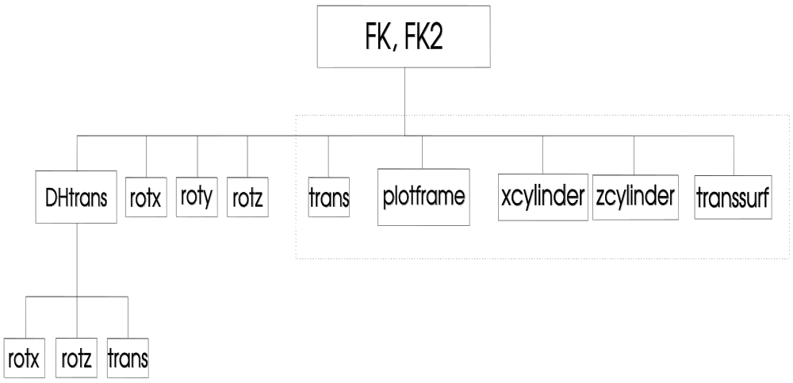

Fig 1: Top-down Chart for the MATLAB functions "FK" and "FK2"
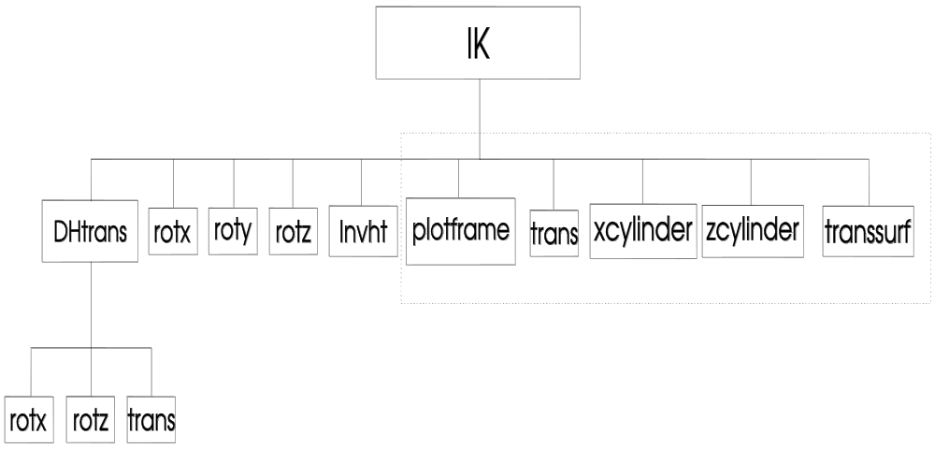

Fig 2: Top-down Chart for the MATLAB function "IK"
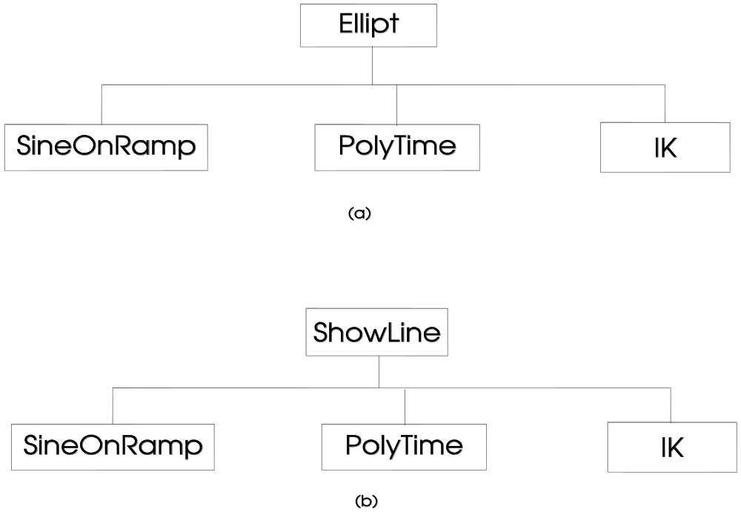

Fig3: Top-down Charts for the MATLAB functions, (a) Ellipt and (b) ShowLine

